Zasm demo

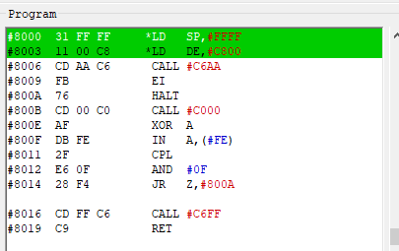

#8000 our stack is set at the top of memory

#8003 load DE with the song data
in this case, song data is at $C800

#8006 initialize the player, _atInit, must have the song address at DE
; Initialize player
; Input:
; DE = song data address

in _atInit

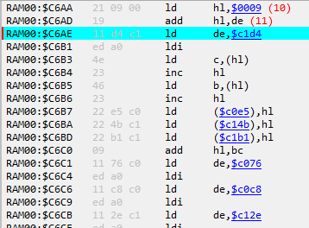

#C6AA ;Skip Header, SampleChannel, YM Clock (DB*3), and Replay Frequency.
#C6AD HL now had song data + data to be skipped ($C809)
#C6AE ld de,_atVAR_SongSpeed + 1
#C6B1 ;Copy Speed.
#C687 contents of HL($C80C instrument data) is put into #C0E5
_atVAR_Track1InstrumentLUT
#C6BA contents of HL($C80C instrument data) is put into #C14B
_atVAR_Track2InstrumentLUT
#C6BD contents of HL($C80C instrument data) is put into #C1B1
_atVAR_Track3InstrumentLUT

